

Practices for Secure Software Report

Table of Contents
Practices for Secure Software Report 1
Document Revision History 3
Client 3
Instructions 3
Developer 4
1. Algorithm Cipher 4
2. Certificate Generation 4
3. Deploy Cipher 4
4. Secure Communications 5
5. Secondary Testing 6
6. Functional Testing 8
7. Summary 9
8. Industry Standard Best Practices 9

Document Revision History

Version | Date | Author | Comments
1.0 | 10/14/2026 | Matthew Owens

Client



Instructions

Submit this completed practices for secure software report. Replace the bracketed text with the relevant information. You must document your process for writing secure communications and refactoring code that complies with software security testing protocols.

- Respond to the steps outlined below and include your findings.
- Respond using your own words. You may also choose to include images or supporting materials. If you include them, make certain to insert them in all the relevant locations in the document.
- Refer to the Project Two Guidelines and Rubric for more detailed instructions about each section of the template.

Developer
Matthew Owens

Algorithm Cipher

I used the SHA-256 hashing algorithm to generate a checksum for the data returned by the application. SHA-256 takes the input data and produces a fixed-length 256-bit hash, which is displayed as a hexadecimal string. This checksum can be used to verify data integrity because changing the input data should produce a different hash. I implemented this using Java's MessageDigest class and converted the resulting bytes into a readable hexadecimal string. SHA-256 is appropriate for this task because it verifies data integrity by producing a consistent hash for the same input. Unlike encryption, hashing is not intended to be reversed to recover the original data.

Certificate Generation
Insert a screenshot below of the CER file.

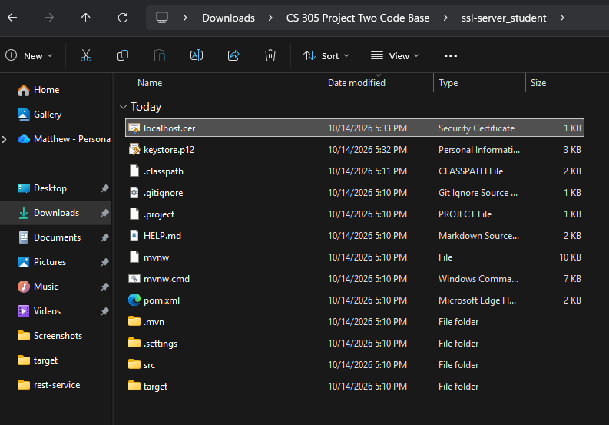

Deploy Cipher
Insert a screenshot below of the checksum verification.

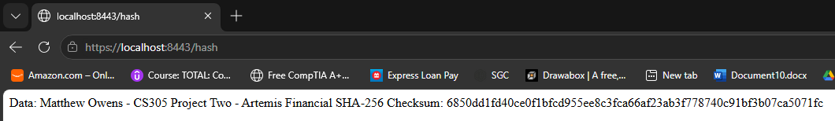

Secure Communications
Insert a screenshot below of the web browser that shows a secure webpage.
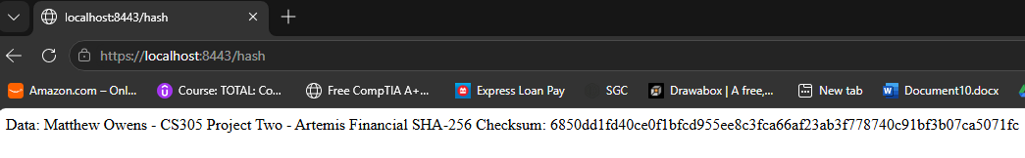

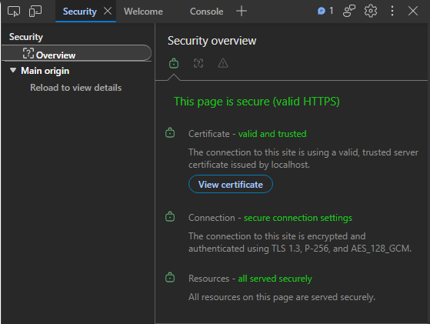
I configured the Spring Boot application to use HTTPS on port 8443 with a PKCS12 keystore and a localhost certificate. The certificate includes localhost and 127.0.0.1 as subject alternative names. After trusting the certificate in my local test environment, I verified that the browser could open the HTTPS endpoint and display the SHA-256 checksum. This demonstrates encrypted communication for local testing. A production service should use a certificate issued by a trusted certificate authority and protect its private key.

Secondary Testing
Insert screenshots below of the refactored code executed without errors and the dependency-check report.

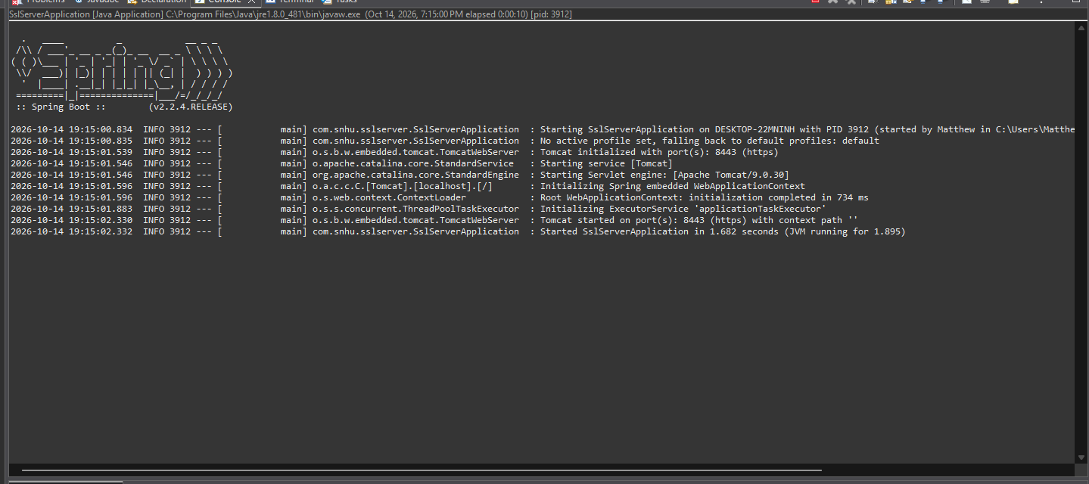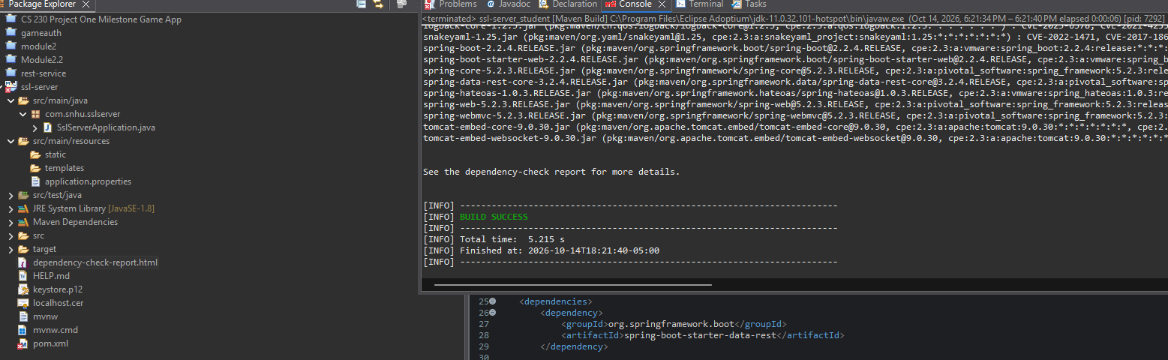
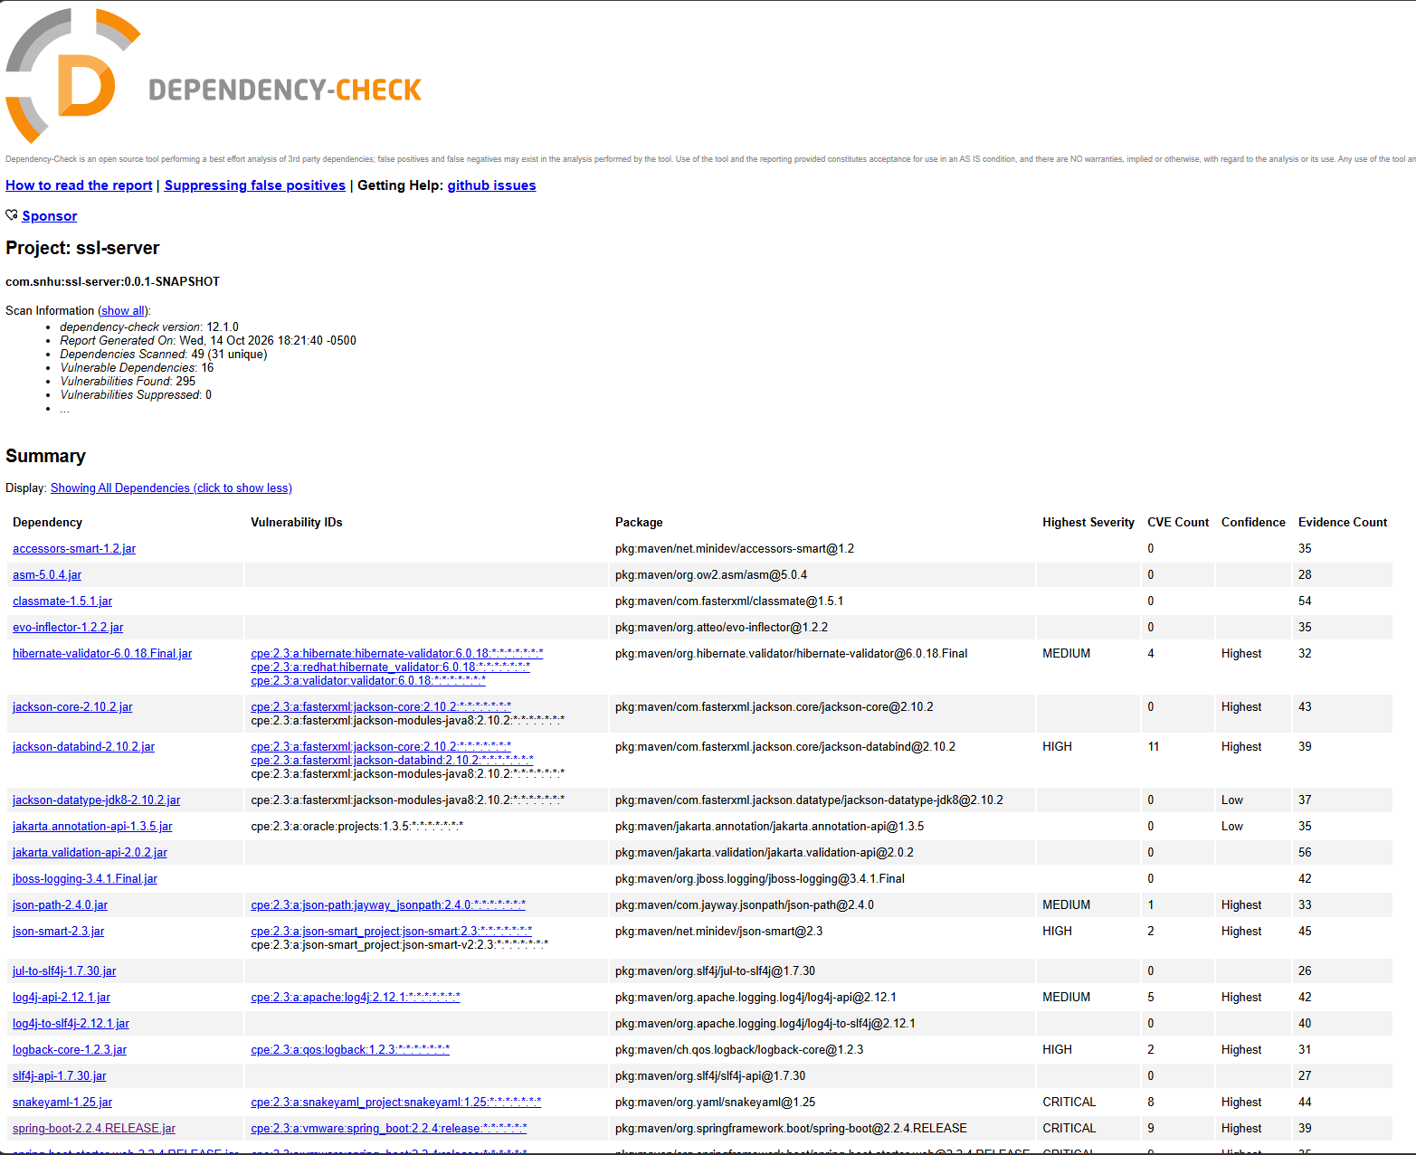

Functional Testing
Insert a screenshot below of the refactored code executed without errors.

I tested the application by starting it in Eclipse and opening https://localhost:8443/hash in the browser. The endpoint returned the configured data and its SHA-256 checksum. The Eclipse Console showed that Tomcat started on port 8443 using HTTPS and that SslServerApplication started successfully. These checks confirmed that the application started and the checksum endpoint responded as expected.

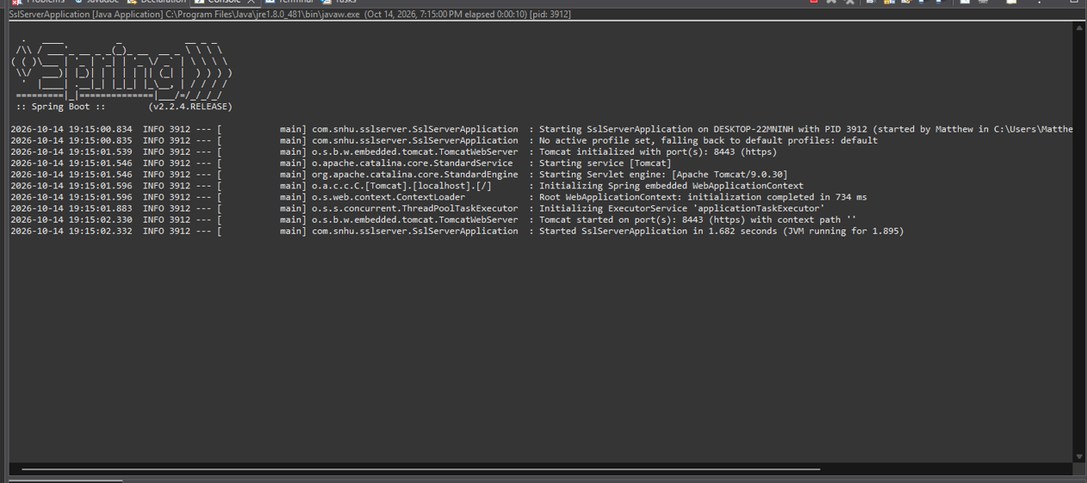

I manually reviewed the refactored code to check that the SHA-256 checksum was generated correctly and returned by the /hash endpoint. I checked that the application started successfully, that the endpoint returned the expected data and checksum, and that the HTTPS configuration used the local PKCS12 keystore. I also reviewed the Dependency-Check results to identify security concerns in the project's third-party libraries. The application passed the startup and checksum tests, but the dependency findings still require attention.

Summary

For this project, I added a SHA-256 checksum to the application and set it up to use HTTPS with a local certificate and keystore. I tested the /hash endpoint in my browser and confirmed that the application started correctly in Eclipse. I also ran OWASP Dependency-Check to look for vulnerabilities in the project's dependencies. The scan found several known vulnerabilities, so those would need to be looked into, and the affected libraries updated or fixed. Overall, this project helped me understand how HTTPS, checksum verification, and dependency scanning can help make an application more secure. This follows the vulnerability assessment process by identifying security risks, making changes to the code, and testing the application to check that it works correctly. Using SHA-256, HTTPS, and Dependency-Check adds different layers of security by checking data integrity, protecting data while it is being transmitted, and identifying known vulnerabilities in third-party libraries.

Industry Standard Best Practices

Industry-standard secure development practices include using HTTPS with current TLS settings, using certificates from a trusted certificate authority in production, and protecting private keys and keystore passwords. For this project, I used a local keystore password to get the application working for testing. In a real application, passwords should be stored securely using environment variables or a secret management system instead of being hard coded in the source code or committed to version control. Developers should also keep frameworks and third-party dependencies updated and use tools like OWASP Dependency-Check to find known vulnerabilities. Any findings should be reviewed and prioritized based on their severity, and vulnerable libraries should be updated or mitigated. Testing should also be done to make sure the application works correctly, protects data integrity, and handles errors properly. Following these practices helps Artemis Financial protect customer information, reduce the risk of security breaches, maintain customer trust, and avoid potential financial losses and damage to its reputation.

